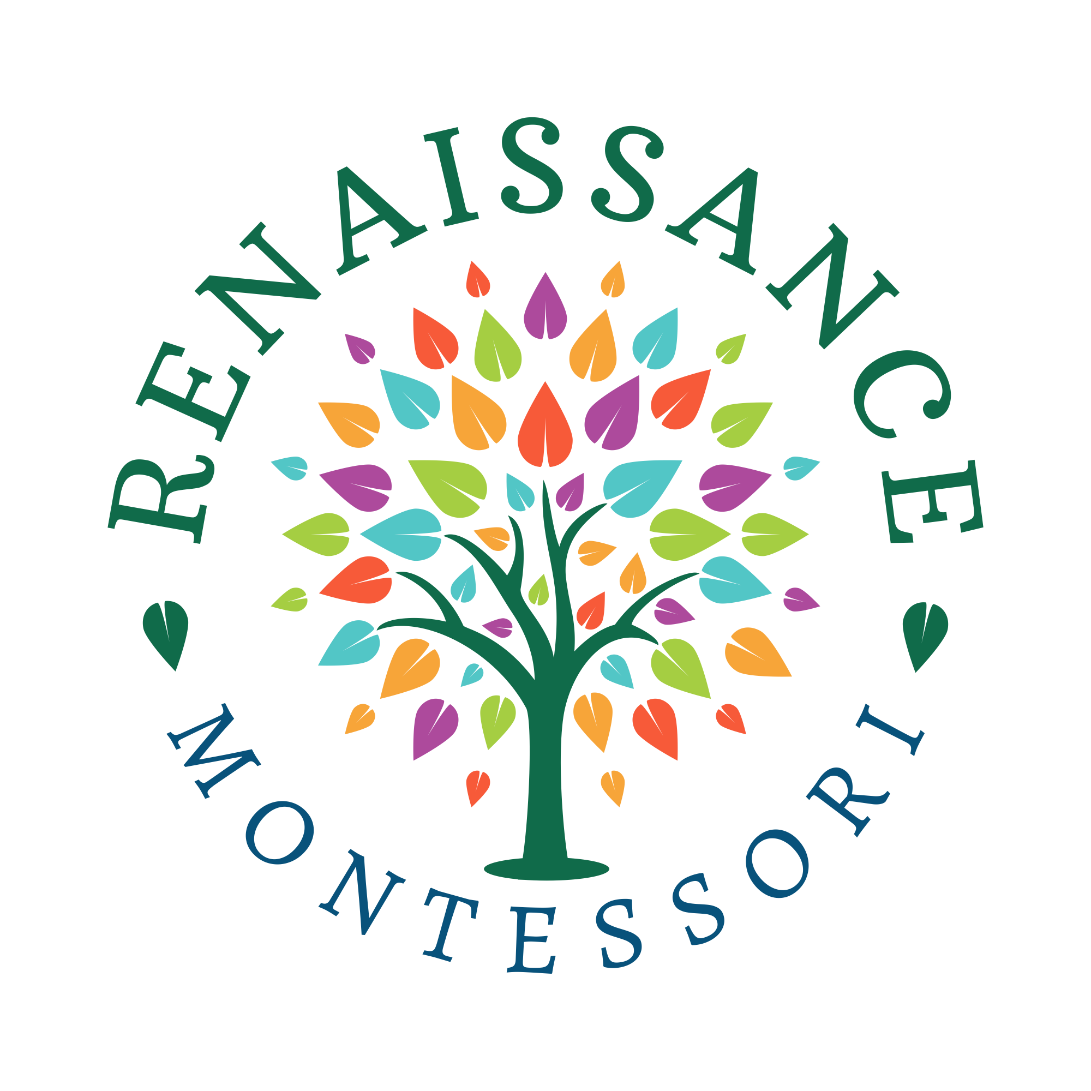
2024-2025 Tuition Agreement
Toddler House

Student’s Name Age Birthdate

Please circle the schedule desired for your child
 | 12 month, 5 days  (Aug through Jul) | 10 month, 5 days  (Aug through May) | Other  (Describe) | Initial  Choice | Amount  $
Monthly | $17,400/year  $1,450/month | $15,500 /year  $1,550/month
3 installments | $16,251/year  $5,417/pmt | $14,466 /year  $4,822/pmt
1 installment | $15,720/year | $14,050/year
Early Bird drop off  (7:45-8:30) | $110/month,  3 pmts of $420,  or 1 pmt of $1,150  (circle) | $115/month,  3 pmts of $370,  Or 1 pmt of $1025  (circle)
After care  (3:00 to 6:00) | Annual snack $75 fee + $275 month,  3 pmts of $970,  or 1 pmt of $2,700  (circle) | Annual snack $60 fee + $300/month,  3 pmts of $900,  Or 1 pmt of $2500  (circle)
Supply and  Snack Fee | $380 | $320
Application / Reenrollment fee | $100 annually
TOTAL | Circle payment plan:  1 time  3 payments  Monthly

NOTES:
- A la carte rates are based on classroom availability and prior approval.
- It is academically and emotionally beneficial for children to attend consistent days.
- Please note that tuition will begin the first day of phase in.

OTHER FEES:
- If paid monthly, tuition is due the first day of each month. If paid in thirds, tuition is due August 1, November 1, and February 1. Late payments fee is $6.00 and accrues daily beginning on the second day of nonpayment. Accounts due past 30 days will accrue a 10% monthly fee.
- A $35 return check fee will be assessed on NSF payments.
- Accounts that have been past due twice may necessitate further explanation on tuition calculations and may require a 20-minute tuition meeting.
- Tuition Reimbursement Forms generated by Renaissance for employers are $5.00/per. Self-generated forms requiring signature are no cost.
- Renaissance uses a payment processing company that has its own fees and charges. Please look at that firm’s agreement documentation for the latest details.

OTHER DISCOUNTS:
- For parents with more than one child enrolled there is a 5% discount for the additional child’s tuition.
- Renaissance Montessori is unable to offer formal scholarships at this time. However, we are always willing to explore alternate payment arrangements to meet our community’s needs.

AGREE TO THE FOLLOWING:

- I understand and agree that tuition at Renaissance Montessori is an annual commitment. Although for convenience it may be paid monthly, I understand that this amount does not vary for months with fewer school days. The total amount due by the end of the school year is as agreed to in this contract, which may be prorated depending on when during the year your family joins the school. Should my family choose to change schools before the end of the year, I understand and agree that Renaissance may at its discretion forgive part of the annual tuition. Initial: _______

- I understand and agree that, should my child be new to Renaissance Montessori, then there will be a 30-day Initial Evaluation period. I understand that four to six weeks is generally ample time from the child’s first day of phase-in to see if the school community is indeed the right fit. During the 30-day Initial Evaluation period, I understand that either my family or the school can withdraw from this contract without penalty. I understand and agree that my child’s tuition must be paid during this time, but any excess funds received by Renaissance Montessori will be pro-rated should this contract be cancelled within the 30-day Initial Evaluation period. Initial: _______

- I understand and agree that make-up days for my child are not available for school closings, days of inclement weather, or absences. Initial: _______

- I understand and agree that tuition, during either the school year and camp, is due according to the schedule in this document; for example, monthly tuition is due on the first day of the month. I understand this obligation is not waved if the student is not able to attend for health or travel reasons on that day. Initial: _______

- I understand and agree that tuition will not be waived for travel or vacation days. Initial: _______

I acknowledge and agree that for the school year my family is committing to paying $_________
in _________ installments of $_______ each. I agree to all of the policies and fees explained in this document.

_________________________________________ _____________________
Parent Signature Date

