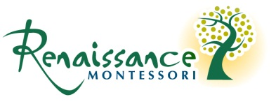

Immunization Records Waiver

I ____________________________, understand that my child ______________________ will not be permitted to attend Renaissance Montessori in the event of an outbreak of any immunized disease until a doctor has approved my child’s return. I understand that Renaissance Montessori makes no representations that its facility is or will be free of any communicable disease. I assume all risks to my child and absolve Renaissance Montessori of all responsibility should my child contract any contagion either on the premises or from any official school activity.

_________________________________
Parent Signature

__________________________
Date

610 Nottingham Drive, Cary NC 27511 919-439-0130 www.Renaissancescholars.com

